**PROJECT ON**

CAR RESALE VALUE PREDICTION

**Powered by IBM India**

Submitted by

YAZHINI V

SINDHU BHARATHI M

VISHAL ANANTH

MANOBALA

# TEAM ID: PNT2022TMID42430

CHRIST THE KING ENGINEERING COLLEGE

KARAMADAI-641104, COIMBATORE

DEPARTMENT OF

COMPUTER SCIENCE & ENGINEERING

**Mentor:** Mr.Vimalaithayan AP/CSE

**Industrial** **Mentor:** Miss.Swetha

|  |  |  |
| --- | --- | --- |
| **SI.No** | **context** | **Page No** |
| 1 | Introduction | 3 |
| 2 | Literature Survey | 4 |
| 3 | Ideation & Proposed Solution | 6 |
| 4 | Requirements Analysis | 10 |
| 5 | Project Design | 11 |
| 6 | Project Planning & Scheduling | 13 |
| 7 | Coding and Solutioning | 14 |
| 8 | Testing | 15 |
| 9 | Result | 17 |
| 10 | Advantages & Disadvantages | 17 |
| 11 | Conclustion | 18 |
| 12 | Future Scope | 19 |
| 13 | Appendix | 21 |

## 

**Introduction**

This project “Car Resale Value Prediction” aims to build a model to predict used cars reasonable prices based on multiple a spects, including vehicle mileage, year of manufacturing, fuel consumption, transmission, road tax, fuel type, and engine size. This model can benefit seller s, buyers, and car manufacturer s in the used car s market. Upon completion, it can output a relatively accurate price prediction based on the information that users input. The model building process involves machine learning and data science. The data set used was scraped from

listings of used cars. Various regression methods, including linear regression, polynomial regression, support vector regression, decision tree regression, and random forest regression, were applied in there search to achieve the highest accuracy. Before the actual start of model-building, this project visualised the data to under stand the data set better. The dataset was divided and modified to fit the regression, thus ensuring the performance of the regression.

**1.1** **Project** **Overview**

´ A car price prediction has been a high interest research area, a s it require s noticeable effort and knowledge of the field expert. Considerable number of distinct attribute s are examined for the reliable and accurate prediction. To build a model for predicting the price of used cars, the applied three machine learning technique s are random forest ,KN-N and linear regression algorithm. Respective performance s of different algorithm s were then compared to find one that be stsuits the available data set. This ability to capture data, analyse it and use it to

personalise a shopping experience or implement is the future of retail.

Parameters involved :

Car name, Year, Selling Price, Present Price, Kms Driven, Fuel type,

Seller type, Transmission, Owner and so on.

# 1.2 Purpose

Car makers face several challenges in the second-hand market. The depth crisis in the European Union, the general problem of overcapacity, increasing competition from Asian manufacturers, and the trend toward more eco-friendly cars are only a few factors that add to the difficulty of selling used vehicles in the second-hand market and decrease sales margins. Therefore, car makers require sophisticated decision support systems to sustain the profitability of the used car business.

**2.** **LITERATURE** **SURVEY**

## 2.1 Existing problem

The problem is defined a s the optimised way to estimate insurance cost based on the manufacturer with some additional costs incurred by the Government in the form of taxes. A s the existing method s for estimating the cost takes a lot of time and energy and due to the increased price of new cars and the inability of customers to buy new cars due to the lack of funds, used cars sales are on a global increase.

The prices of new cars in the industry is fixed by the So, customers buying a new car can be assured of the money they invest to be worthy. There is a need for a used car price prediction system to effectively determine the worthiness of the car using a variety of features. Even though there are web site s that offer this service, their prediction method may not be the best. Beside s, different models and systems may contribute to predicting power for a used car’s actual market value. It is important to know their actual market value while both buying and selling.

**2.2** **References**

[1] Sameerchand Pudaruth, “Predicting the Price of Used Cars using Machine Learning Techniques”; (IJICT 2014)

[2] Enis gegic, Becir Isakovic, Dino Keco, Zerina Masetic, Jasmin Kevric, ”Car Price Prediction Using Machine Learning”; (TEM Journal 2019)

[3] Ning sun, Hongxi Bai, Yuxia Geng, Huizhu Shi, “Price Evaluation Model In Second Hand Car System Based On BP Neural Network Theory”;

(Hohai University Changzhou, China)

[4] Nitis Monburinon, Prajak Chertchom, ThongchaiKaewkiriya, Suwat Rungpheung, Sabir Buya, PitchayakitBoonpou, “Prediction of Prices for

Used Car by using Regression Models” (ICBIR 2018)

[5] Doan Van Thai, Luong Ngoc Son, Pham Vu Tien, NguyenNhat Anh, Nguyen Thi Ngoc Anh, “Prediction car pricesusing qualify qualitative data

and knowledge-based system” (Hanoi National University)

At present, under the guidance of the new generation of information technology, the rapid accumulation of data, the continuous improvement of computing power, the continuous optimization of algorithm models, and the rapid rise of multi-scene applications have made profound changes in the development environment of Machine Learning.

**2.3 Problem statement definition**

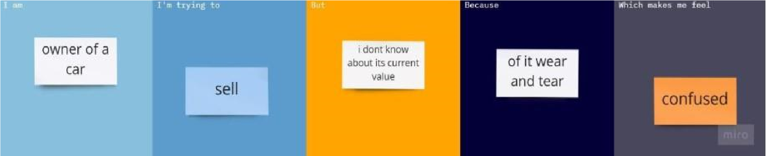

**Ideation & Proposed Solution**

**Empathy** **Map** **Canvas**

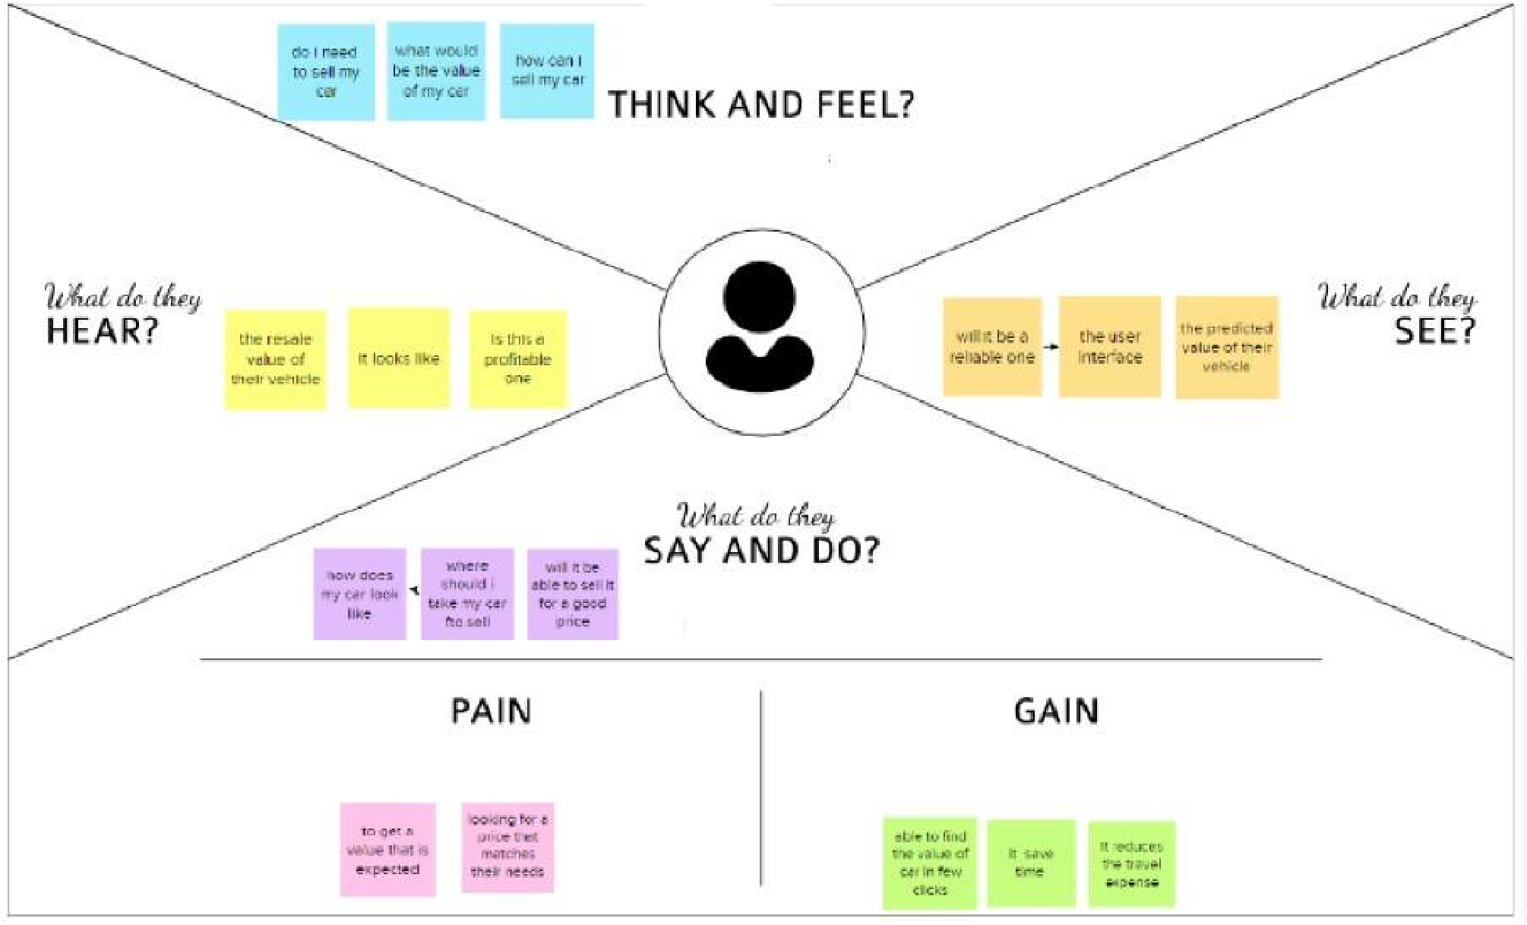

**Ideation** **&** **Brainstorming**

**STEP** **1:**

* + - Prediction using Car image. By using the exterior and interior image of the car.
    - The value will be predicted based on the appearance of the car. If there any damage or n numbers scratches the car resale value will be quite affected.
    - By using neural network value of the car can be predicted.
    - Neural network algorithm is developed by considering the human brain that takes a set of units as input and transfers results to a predefined output.

**STEP** **2:**

* + - The main objective of this project is to predict the Prices of used cars, compare the prices and also estimate the lifespan of a particular car. o Insurance, Company claims,etc. o regression Algorithm is used to predict the value.
    - Regression model based on k-nearest neighbour machine learning algorithm was used to predict the price of a car.

**STEP** **3:**

* + - Prediction using engine car condition.
    - User should upload engine sound in the format of audio file.
    - By using Convolutional Neural Networks methodology price can be

predicted.

* + - CNNs for Machine Learning on sound data by spectrogram approach that was just converts each song (or song segment) into a spectrogram: a two dimensional matrix

**STEP 4:**

* Economic Conditions. o Kilo-metres Covered.
  + - Its mileage (the number of kilometres it has run) and its horsepower
    - Car prediction using XGBoost algorithm accurate results will be monitored.
    - XGBoost as a regression model gave the best M SLE and RM SE values.

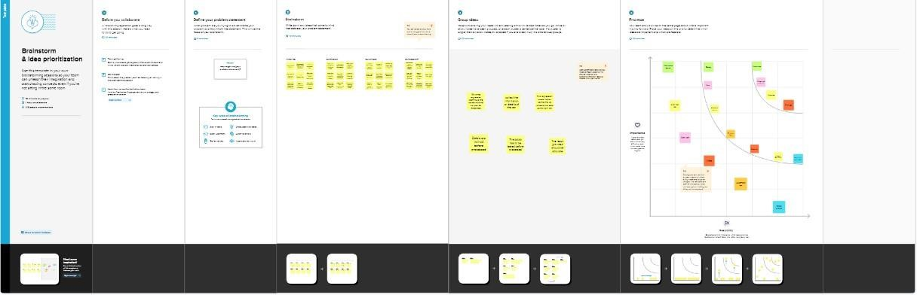

**Proposed** **Solution:**

|  |  |  |
| --- | --- | --- |
| **S.No.** | **Parameter** | **Description** |
| 1. | Problem Statement (Problem to be solved) | Car makers face several challenges in the second-hand market. The depth crisis in the European Union, the general problem of overcapacity, increasing competition from Asian manufacturers, and the trend toward more eco-friendly cars are only a few factors that add to the difficulty of selling used vehicles in the second-hand market and decrease sales margins. Therefore, car makers require sophisticated decision support systems to sustain the profitability of the used car business. |
| 2. | Idea / Solution description | The main aim of this project is to predict the price of used cars using the various Machine Learning(ML) models. This can enable the customers to make decisions based on different inputs or factors namely, Brand or Type of the car, Model of the car, Location, Year of manufacturing, Type of fuel, Price range or Budget, Mileage to name a few characteristic features required by the customer. The project Car Resale Value Prediction deals with providing the solution to these problems. Through this project, we will get to know which of the factors are significant and tell us how they affect the car’s worth in the market. |
| 3. | Novelty / Uniqueness | Deciding whether a used car is worth the posted price when you see listings online can be difficult. Several factors, including mileage, make, model, year, etc. can influence the actual worth of a car. |
| 4. | Social Impact / Customer Satisfaction | Customers are highly satisfied with high resale value. In this prediction is used to customer can easily find and buy the car he was looking forward to. |
| 5. | Business Model (Revenue Model) | With difficult economic conditions, it is likely that sales of second-hand imported (reconditioned) cars and used cars will increase. In many developed countries, it is common to lease a car rather than buying it outright. After the lease period is over, the buyer has the possibility to buy the car at its residual value |
| 6. | Scalability of the Solution | The implementation of our solution helps to find the accurate value of the used care. In order to predict the resale value of the car, we proposed an intelligent, flexible, and effective system that is based on using regression algorithms. We will be using various regression algorithms and algorithm with the best accuracy will be taken as a solution, |

**Proposed** **Solution** **fit**

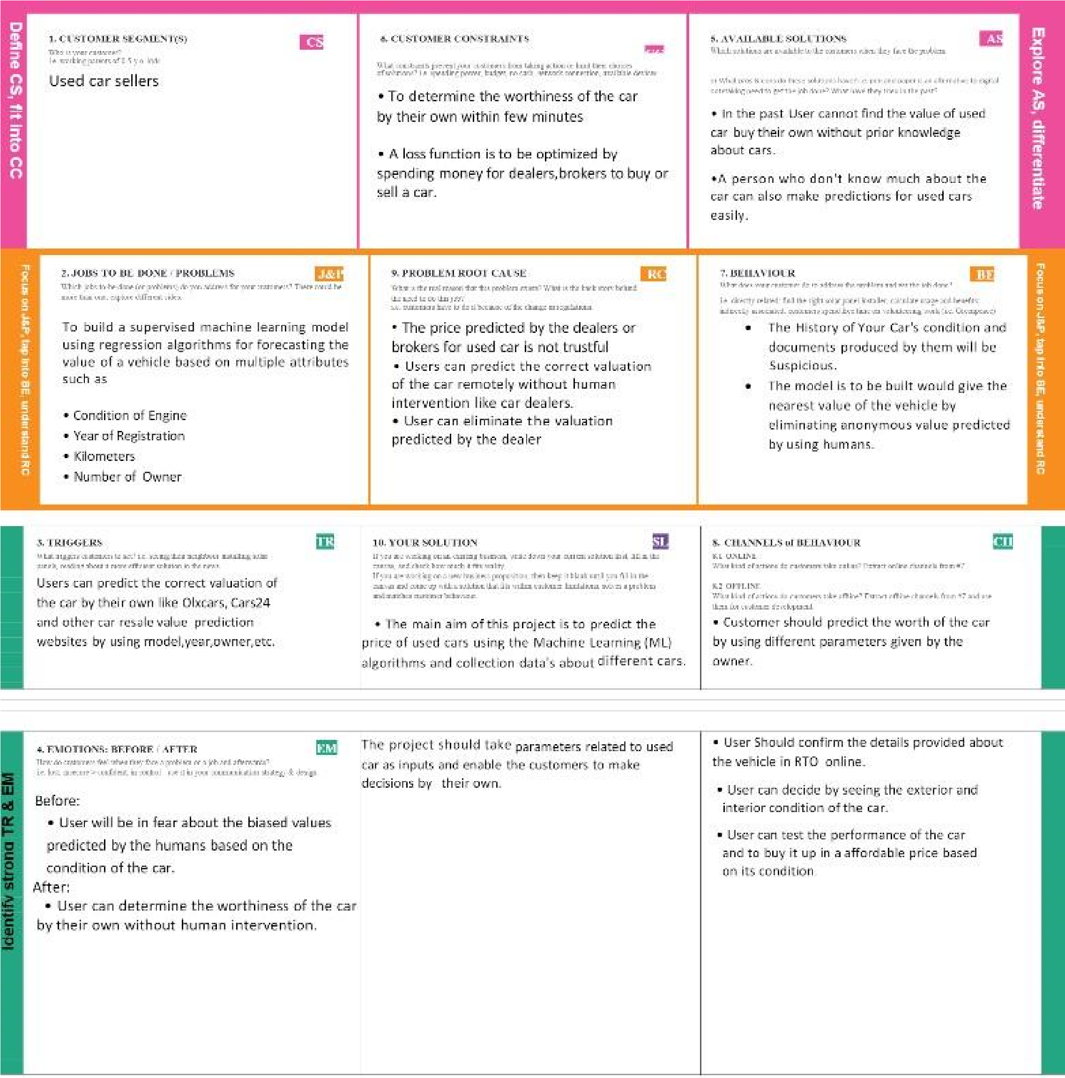

**REQUIREMENT** **ANALYSIS**

**Functional** **Requirement**

The functional Requirements of this projects involves the better understanding of

Pre-processing, Application designing using HTML & CSS and

IBM Watson Cloud. IBM Watson provides the services such as Database, deployment etc.

Hardware requirements Operating system- Windows 7,8,10

Software Requirements

* + - Python
    - VS code
    - PIP 2.7
    - Jupyter Notebook
    - Chrome

**Non** **Functional** **Requirement**

The Non - Functional Requirements of this project are,

* + - Highly accurate Image Predictive model
    - better user responsive web application
    - Cloud database for storing the informations

**PROJECT** **DESIGN**

* 1. **Data** **Flow** **Diagrams**
  2. **Solution** **&** **Technical** **Architecture**

**5.2** **Solution** **&** **Technical** **Architecture**

**5.2** **Solution** **&** **Technical** **Architecture**

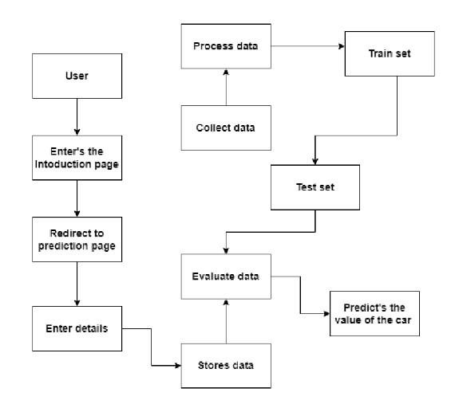

|  |  |  |  |  |  |  |
| --- | --- | --- | --- | --- | --- | --- |
| **Sprint** | **Functional**  **Requirement (Epic)** | **User Story**  **Number** | **User Story / Task** | **Story Points** | **Priority** | **Team**  **Members** |
| Sprint-1 | Pre-process data | USN-1 | Collect Dataset | 1 | Low | Yazhini V |
| Sprint-1 |  | USN-2 | Import required libraries | 1 | Low | Sindhu  Bharathi M |
|  |  | USN-3 | Read and clean data sets | 2 | Low | Vishal Ananth R |
| Sprint-2 | Model building | USN-1 | Split data into independent and dependent variables | 3 | Medium | Manobala F |
| Sprint-2 |  | USN-2 | Apply using regression model | 3 | Medium | Yazhini V |
| Sprint-3 | Application building | USN-1 | Build python flask application and HTML page | 5 | High | Sindhu  Bharathi M |
| Spint-3 |  | USN-2 | Execute and test | 5 | High | Manobala F  & Vishal  Ananth R |
| Spint-4 | Training the model | USN-1 | Train machine learning model | 5 | High | Sindhu  Bharathi M |
| Spint-4 |  | USN-2 | Integrate flask | 5 | High | Sindhu  Bharathi M &  Vishal Ananth |

* 1. **Solution** **&** **Technical** **Architecture**

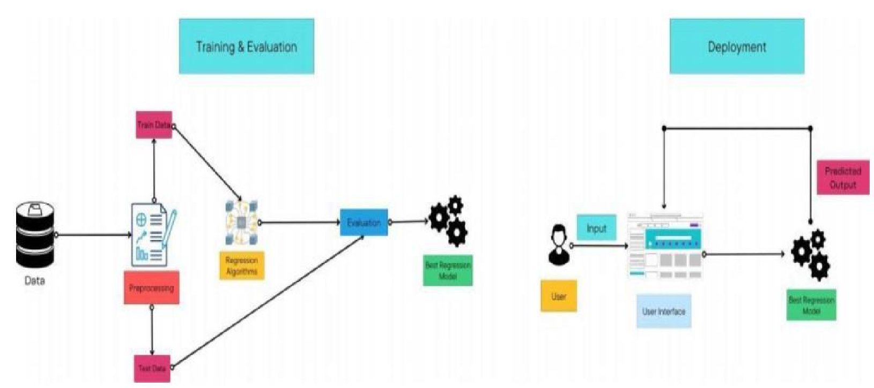

* 1. **User** **Stories**

**PROJECT** **PLANNING**

**6.1** **Sprint** **Planning** **and** **Estimation**

## 6.2 Sprint Delivery Schedule

* Pre -requisites
* Import Required libraries
* Collect Data Set
* Pre the process the data
* Choose the Appropriate Model
* Train the model on IBM
* Integrate with Flask endpoint
* Index..html
* Regi stration form.html
* Fla sk application
* App.py

7. CODING & SOLUTION

### Feature 1

### 7.2 Feature 2

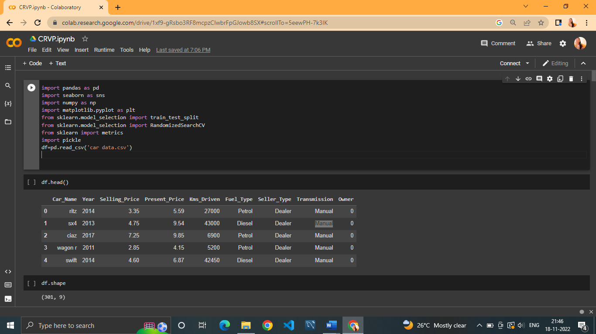

from flask import Flask, render_template, request

import pickle

import numpy as np

from sklearn.preprocessing import StandardScaler

app = Flask(__name__)

model = pickle.load(open('random_forest_regression_model.pkl', 'rb'))

@app.route('/',methods=['GET'])

def Home():

    return render_template('base.html')

standard_to = StandardScaler()

@app.route('/predict_page')

def predict_page():#predicting page

    return render_template('index1.html')

@app.route("/predict", methods=['POST'])

def predict():

    Fuel_Type_Diesel=0

    if request.method == 'POST':

        Year = int(request.form['Year'])

        Present_Price=float(request.form['Present_Price'])

        Kms_Driven=int(request.form['Kms_Driven'])

        Kms_Driven2=np.log(Kms_Driven)

        Owner=int(request.form['Owner'])

        Fuel_Type_Petrol=request.form['Fuel_Type_Petrol']

        if(Fuel_Type_Petrol=='Petrol'):

                Fuel_Type_Petrol=1

                Fuel_Type_Diesel=0

        else:

            Fuel_Type_Petrol=0

            Fuel_Type_Diesel=1

        Year=2020-Year

        Seller_Type_Individual=request.form['Seller_Type_Individual']

        if(Seller_Type_Individual=='Individual'):

            Seller_Type_Individual=1

        else:

            Seller_Type_Individual=0

        Transmission_Mannual=request.form['Transmission_Mannual']

        if(Transmission_Mannual=='Mannual'):

            Transmission_Mannual=1

        else:

            Transmission_Mannual=0

        prediction=model.predict([[Present_Price,Kms_Driven2,Owner,Year,Fuel_Type_Diesel,Fuel_Type_Petrol,Seller_Type_Individual,Transmission_Mannual]])

        output=round(prediction[0],2)

        if output<0:

            return render_template('index1.html',prediction_texts="Sorry you cannot sell this car")

        else:

            return render_template('index1.html',prediction_text=" (You Can Sell the Car at){}".format(output))

    else:

        return render_template('index1.html')

if __name__=="__main__":

    app.run(debug=True)

1. **TESTING**

**8.1.** **Test** **Cases**

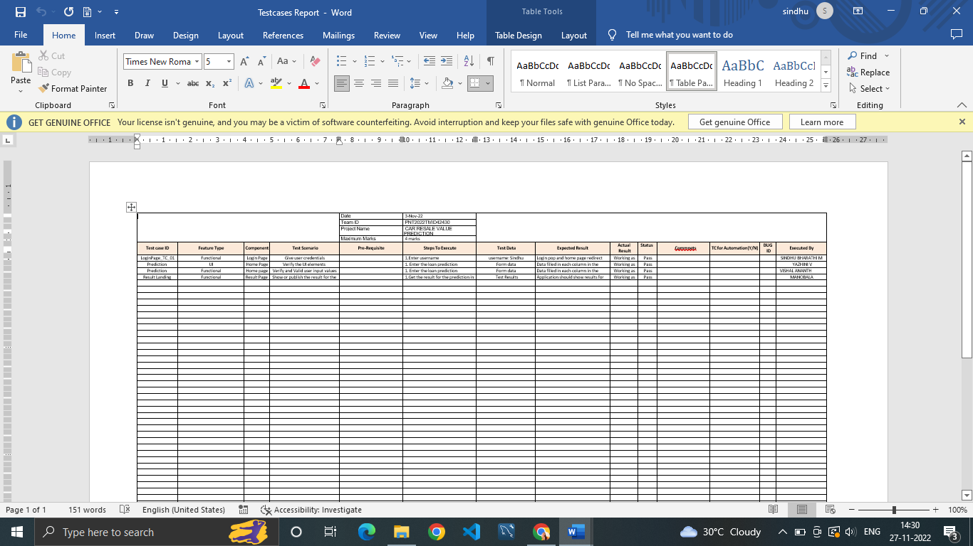

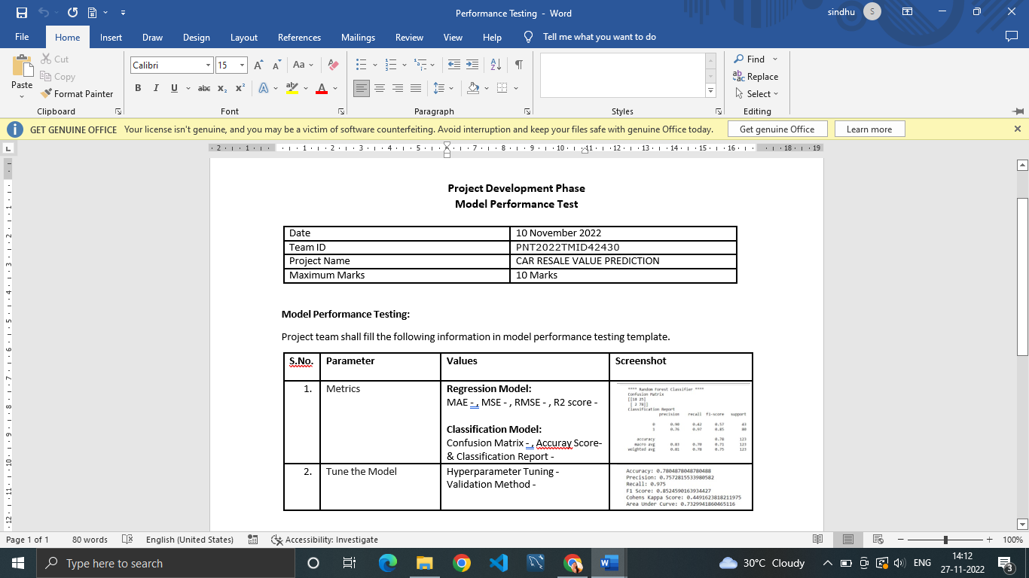

**8.2.** **User** **Acceptance** **Testing**

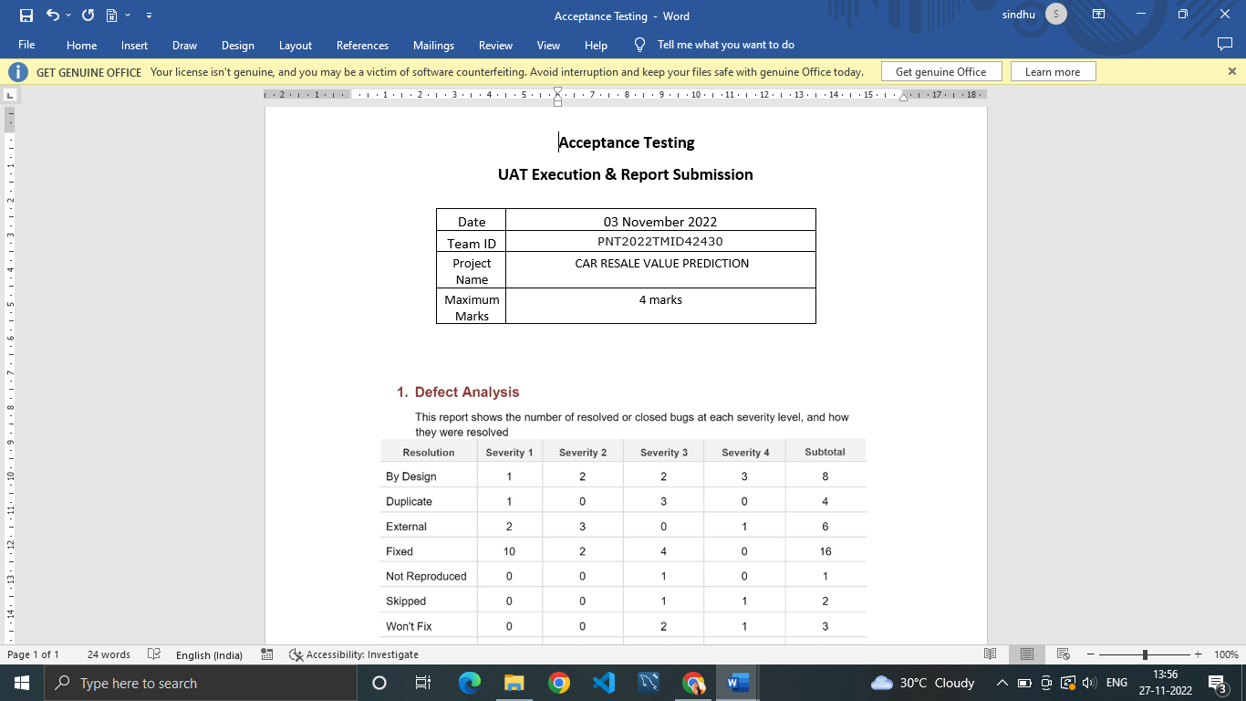

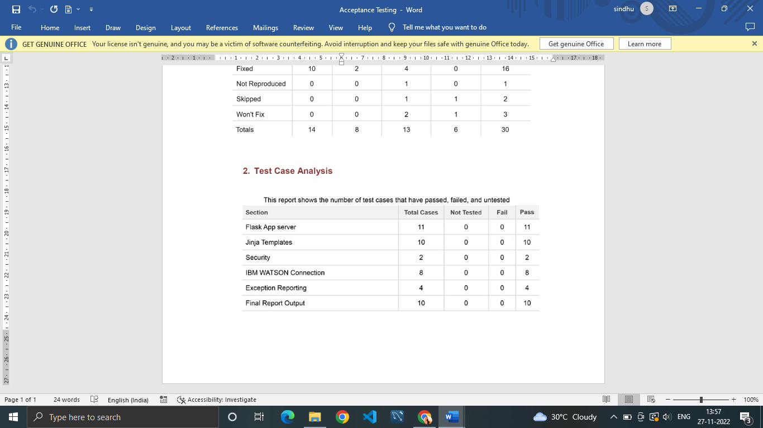

1. **RESULT**

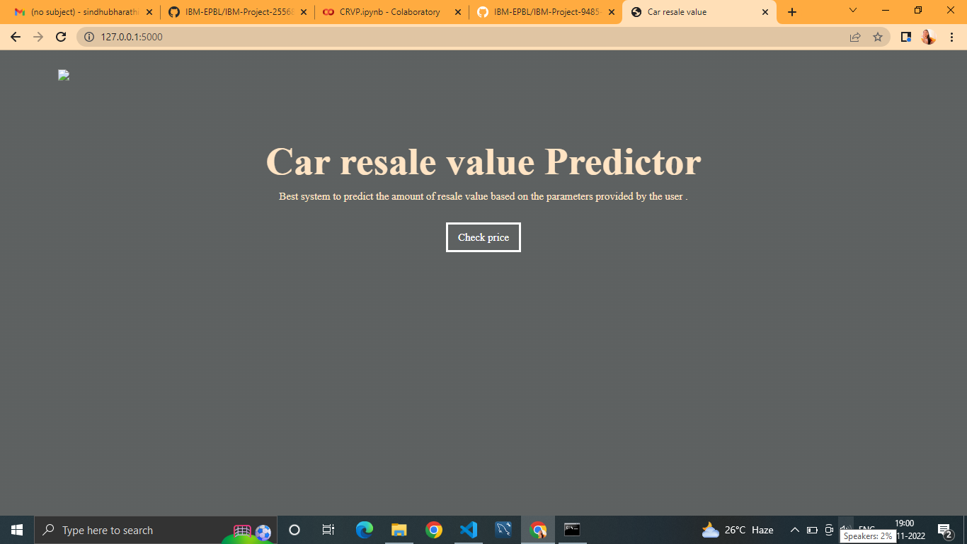

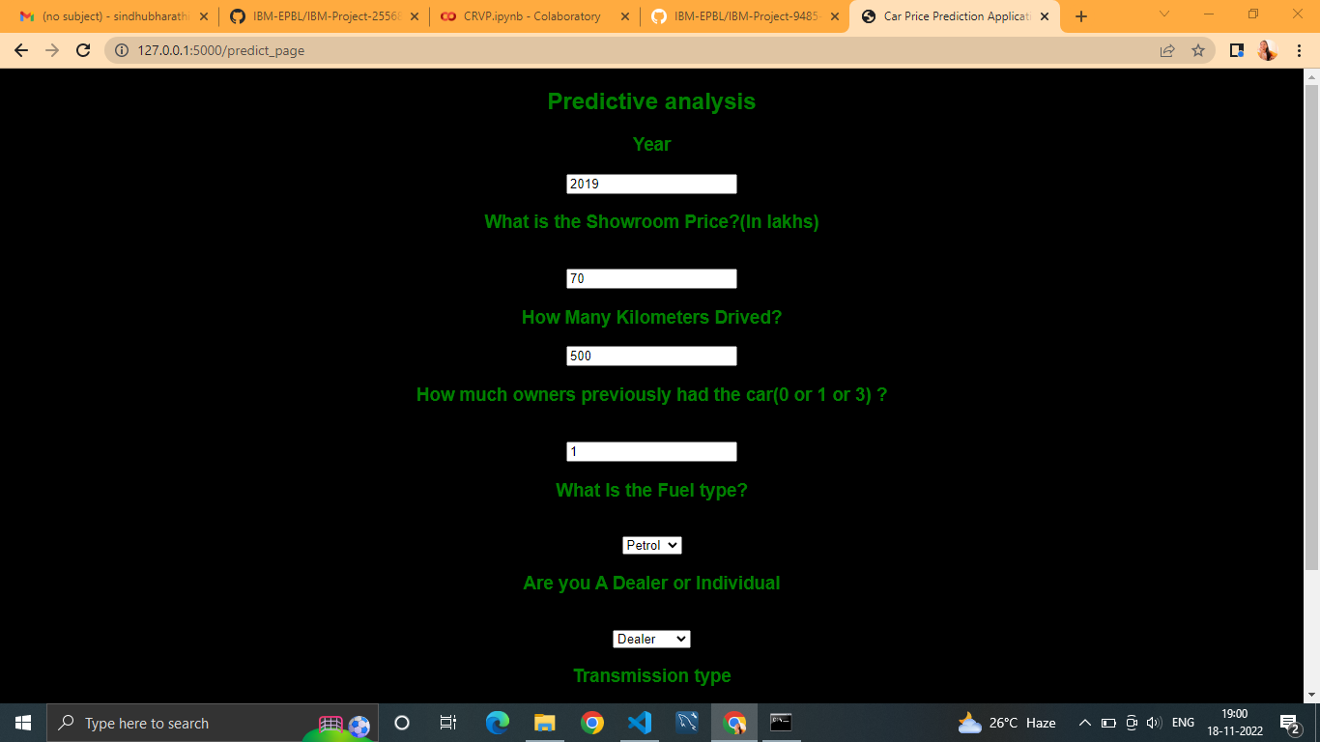

The login web page is tested with the invalid user information to check the invalid login testing into the webpage.

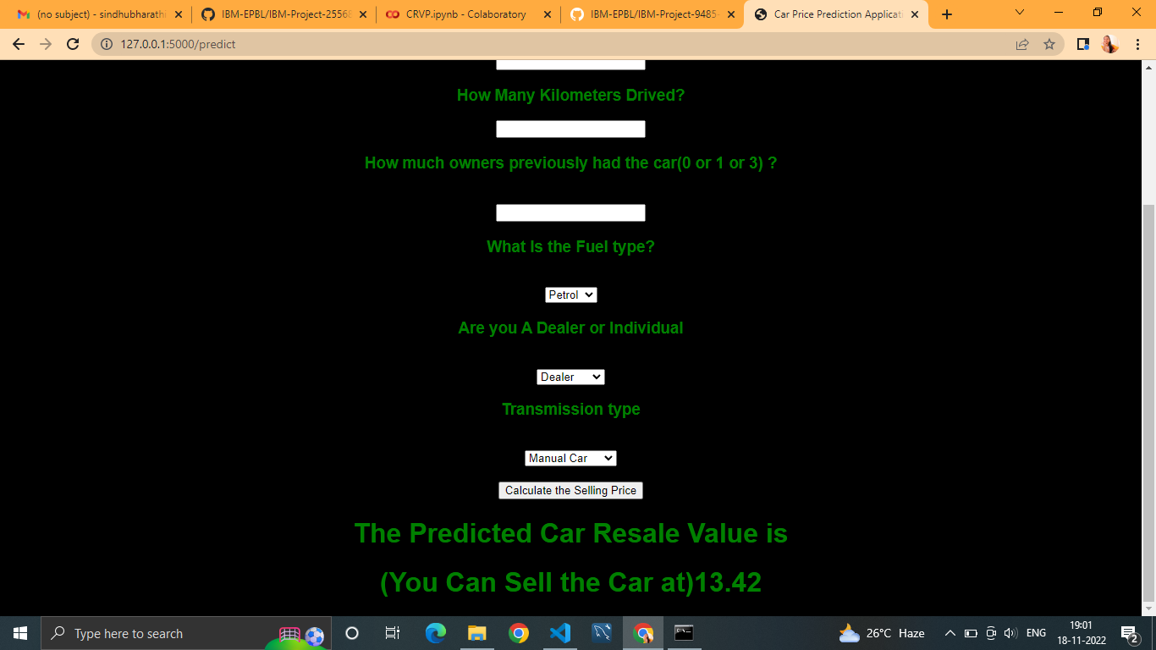

**9.2** **Performance** **metrics**

**{'mae':** **1325.112086905962,**

**'mse':** **9577053.62710202,**

**'rmse':** **3094.6815065692977,**

**'rmsle':** **8.03744027403009,**

**'r2':** **0.8661221626879432,**

**'adj** **r2** **score':** **0.8661152969113608}**

The model is tested with the various damaged car images which is not used during the training and validation of the model which also shows that the model works with the accuracy of about 98% in the overall performance

1. **ADVANTAGES** **AND** **DISADVANTAGES**

* To develop an efficient and effective model which predicts the price of a used car according to the user's inputs and achieve good accuracy.

**CONS:**

* Less effective

**11.** **CONCLUSION**

The increased prices of new cars and the financial incapability of the customers to buy them, Used Car sales are on a global increase. Therefore, there is an urgent need for a Used Car Price Prediction system which effectively determines the worthiness of the car using a variety of features. The proposed system will help to determine the accurate price of used car price prediction.

**12.F** **UT** **U** **R** **E** **SCO** **P** **E**

In future this machine learning model may bind with various websites which can provide real time data for price prediction. Also we may add large historical data of car price which can help to improve accuracy of the machine learning model. We can build an android app as a user interface for interacting with users. For better performance, we plan to judiciously design deep learning network structures, use adaptive learning rates and train on clusters of data rather than the whole dataset.

**APPENDIX**

**App.py**

from flask import Flask, render_template, request

import pickle

import numpy as np

from sklearn.preprocessing import StandardScaler

app = Flask(__name__)

model = pickle.load(open('random_forest_regression_model.pkl', 'rb'))

@app.route('/',methods=['GET'])

def Home():

    return render_template('base.html')

standard_to = StandardScaler()

@app.route('/predict_page')

def predict_page():#predicting page

    return render_template('index1.html')

@app.route("/predict", methods=['POST'])

def predict():

    Fuel_Type_Diesel=0

    if request.method == 'POST':

        Year = int(request.form['Year'])

        Present_Price=float(request.form['Present_Price'])

        Kms_Driven=int(request.form['Kms_Driven'])

        Kms_Driven2=np.log(Kms_Driven)

        Owner=int(request.form['Owner'])

        Fuel_Type_Petrol=request.form['Fuel_Type_Petrol']

        if(Fuel_Type_Petrol=='Petrol'):

                Fuel_Type_Petrol=1

                Fuel_Type_Diesel=0

        else:

            Fuel_Type_Petrol=0

            Fuel_Type_Diesel=1

        Year=2020-Year

        Seller_Type_Individual=request.form['Seller_Type_Individual']

        if(Seller_Type_Individual=='Individual'):

            Seller_Type_Individual=1

        else:

            Seller_Type_Individual=0

        Transmission_Mannual=request.form['Transmission_Mannual']

        if(Transmission_Mannual=='Mannual'):

            Transmission_Mannual=1

        else:

            Transmission_Mannual=0

        prediction=model.predict([[Present_Price,Kms_Driven2,Owner,Year,Fuel_Type_Diesel,Fuel_Type_Petrol,Seller_Type_Individual,Transmission_Mannual]])

        output=round(prediction[0],2)

        if output<0:

            return render_template('index1.html',prediction_texts="Sorry you cannot sell this car")

        else:

            return render_template('index1.html',prediction_text=" (You Can Sell the Car at){}".format(output))

    else:

        return render_template('index1.html')

if __name__=="__main__":

    app.run(debug=True)

**Github** **Repo:** <https://github.com/IBM-EPBL/IBM-Project-7348-1658853071>

**Demo_Video:** [**https://github.com/IBM-EPBL/IBM-Project-7348-1658853071/blob/main/Final%20Delivery/Video_Demo/Demo%20Video.mp4**](https://github.com/IBM-EPBL/IBM-Project-7348-1658853071/blob/main/Final%20Delivery/Video_Demo/Demo%20Video.mp4)